Church Walk Primary School DT Scheme of Work
Springfield Cycle Year 5 / 6 Cycle B |  | Year 5 Year 6 |  | Key Assessment Criteria
 | Autumn | Spring | Summer
Focus | Structures:  Anderson Shelters  (strengthen, stiffen, reinforce)    WW2 Rationing and cooking  Dig for Victory | Levers: Ancient Egyptian Challenges  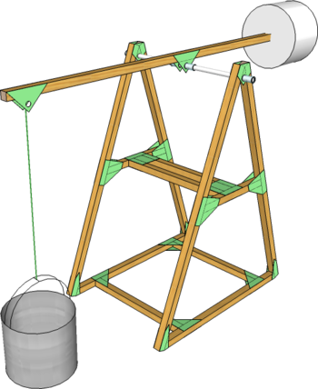 | Textiles  (new topic)  STEM Programmable computers (one off day) | - I can come up with a range of ideas after collecting information from different sources  - I can produce a detailed, step-by-step plan  - I can suggest alternative plans;outlining the positive features and draw backs  - I can explain how a produt will appeal to a specific audience  - I can evaluate appearance and function against original criteria  - I can use a range of tools and equipment competently  - I can make a prototype before I make a final version  - I can show that I can be both hygienic and safe in the kitchen  - I can use market research to inform my plans and ideas  - I can follow and refine my plans  - I can justify my plans in a convincing way  - I can show that I consider culture and society in my plans and designs  - I can show that I can test and evaluate my products  - I can explain how products should be stored and give reasons  - I can work within a budget  - I can evaluate my product against clear criteria
Resources | Colletions of books, picures, DVDs, internet showing different shelters  Paper straws, dowel, square-section wood,pipe-cleaners, masking tape,paper fasteners,PVA, wood glue, plastic tube to join dowelling, card, fabric, cotton, plastic bags (for sheeting)thread, string, needles  Model figure or doll to use for scale | Visual resources to stimulate designs  Square section wood, card, string, masking tape, containers for buckets, range of suitable adhesives,  G clamps, hacksaws, sandpaper, drills
Curriculum links | History WW2  Literacy- notes, labels, annotations, non-fiction reading | History :The Egyptians  Maths : measurement  Literacy: non-fiction reading, note making  Speaking and listening: describing observations | Science : circuits  Computing: control and monitoring  Literacy: communicating ideas linked to knowledge of different text types  Speaking and Listening: strategies for talking in groups
Skills | Generate ideas  Plan what to do next  Select appropriate tools, materials, components  Explain choices  Produce annotated diagrams  Measure, mark out, cut and assemble  Use ICT for researching and designing  Techniques for reinforcing and strengthening materials  Use bench hook / G-cramp hacksaw safely

